Reflections on 3 forms of CPD undertaken.

- Warwick Leadership Programme.
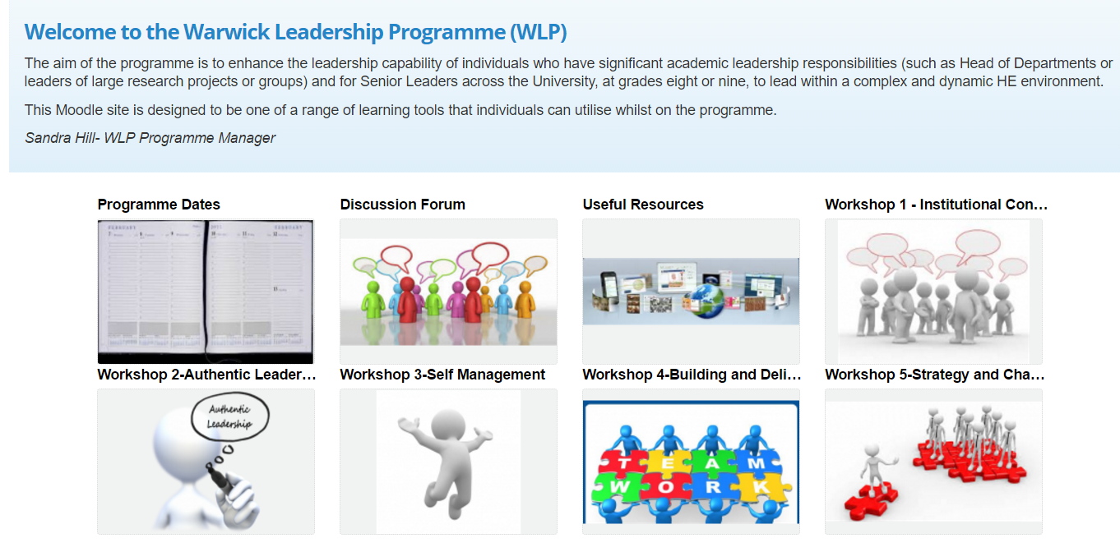

I completed this course in 2015-16. The course took place in 5 face to face all day sessions and this was complimented by resources delivered through moodle. The face-to-face sessions included presentations by a range of senior managers at Warwick from different parts of the institution, talking about their experiences and prompting discussion and reflection in small groups. The course facilitators created a relaxed yet purposeful atmosphere in which to exchange ideas and one of the most useful aspects of the course was the discussion that took place between participants. There were some useful resources but the moodle course was not really well used, it did not become a useful third space for discussion between sessions as I had hoped.
In general the course did give me some good tools for my role and I took advantage of the mentoring and 365 feedback process that were available. However, since restructuring in my work area I have not had the opportunity to put much of it into action as I now have less management involvement. I could not see therefore that there had been awareness institutionally of my participation and there was no completion certificate or record other than the moodle course which still remains available at present.

- #LTHEchat
This regular twitter chat for HE professionals has been a useful network. Running most Wednesday evenings on a topic moderated by an expert in the area, I came across it one week and made it a regular event, adding a participant badge to my website and wearing the physical badge on my lanyard with pride. When the call came for moderators I put myself forward and worked with a small team liaising with moderators, preparing the blog posts, facilitating the chats and then storifying and making visualisations for a term in 2016. As a team member I learned how to use tags explorer for the visualisations and enjoyed getting to know new folk. The team were supportive, those who have been on the organising team before are always very encouraging and present in the chats, a real community emerges from being empowered in this way.
I recently collected my organising team member badge and added that to my website too. Having spent lots of time online and developed skills in moderation I really enjoyed taking this role and connecting with other like-minded educators. Participation in such networks has been an area of CPD that has grown rapidly in my life as it meets my own training needs rather than ticking a box for someone who does not really know me. I have participated in creativeHE, 12 apps of Christmas and others since and I have adopted some of the approaches in my own work with Warwick International Higher Education Academy.

- Moocs
I have completed several moocs including Future Learn’s Dyslexia and Foreign Language Teaching (April 2015) and LERMOOC (on Emma platform).
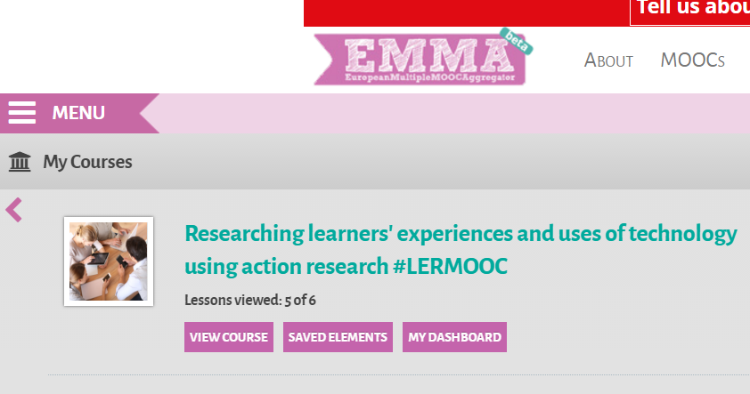

These opportunities to learn in your own time without cost are useful and sometimes provide some opportunities to network and find connections. The resources tend to follow a rather predictable formula that is quite easily gamed. Each topic often has a video presentation, a set of readings, some tasks to complete such as forum posts/replies and possibly a synchronous event. Both of these courses provided good resources and the FL course was particularly well moderated with lots of interaction and discussion. The Lermooc course was rather rushed and could have been better spaced fortnightly rather than every week but the tasks were interesting and they were responsive and re-opened the course when I mentioned that I had not finished. I think such courses do have a place in CPD but I am sceptical about the delivery model as it tends to follow rather dull formats, on such courses you are a consumer rather than an actor.
I have also participated in xMoocs such as #Change11 and they are much more interesting as a participative opportunity to work online on a project of your own choosing. These courses really use the affordances of the web and increase digital capability if you put your mind to them. I remember meeting with folk in Second Life to discuss potentials for learning and it was through this course that I first experimented with curating the web. Since those days others have picked up the baton and online shared activities such as #digiwrimo and #rhizo have provided more authentic opportunities to create together online. I think these sorts of communities will continue to pop up as long as the web remains open and free and it is important that it does in order to prevent commercial interests reinforcing the existing access to education issues we see already in life. The courses are generally inclusive and welcoming but can be daunting if you are not used to working online.

