WIHEA Student Engagement Programme

Final Project Report 2016

Project Team - Staff:
Project Lead Name |  | Department / Centre |  |  | Email
Teresa MacKinnon |  | SMLC |  |  | t.mackinnon@warwick.ac.uk
Academic Lead Partner Name |  | Department / Centre |  |  | Email
Dr. Zhiyan Guo, Dr David Lees and Claude Trégoat. |  | SMLC |  |  | d.w.lees@warwick.ac.uk, zhiyan.guo@warwick.ac.uk , c.s.i.tregoat@warwick.ac.uk
Project Team - Student(s): (If more than 3 students, please provide the same details in the ‘Other Information’ section)
Student Name | Course Title & Year of Study |  | Department |  |  | Email
Grace Bend | 3 language degree Y1 |  | SMLC |  |  | G.Bend@warwick.ac.uk
Gertrud Kiss | Sociology Y1 |  | Sociology |  |  | G.Kiss@warwick.ac.uk
Abbie-Jayne Burford | 3 language degree Y1 |  | SMLC |  |  | a.burford@warwick.ac.uk
Please list any changes to the original team members: (with reasons for change)

Alice Woodman – withdrew “too busy to take part in this project”
Amy Gill – withdrew “Unfortunately I don't think I will be taking part in this project as I am feeling quite stressed with exams at this time”
Fiona Brewis –withdrew “I'm so sorry but I'm going to have to pull out of the project as what with exams and other things coming up I don't have the time to dedicate to the project anymore. I'm really sorry as I was keen to participate, but I have realised if I take anything more on my life will become very stressful. Hope all goes well with the project, apologies for the inconvenience.”
David Lees: staff member was on paternity leave during the project.

Project Title:
Teaching and learning languages in the digital age.

Other Collaborative Partners: (if applicable)
Name |  |  |  | Department / Centre
Tracy Dix/Kate Courage |  |  |  | Library
Start Date of Project: |  | Estimated End Date of Project: |  |  | Actual Date of Completion:
1st April 2016 |  | July 31st 2016 |  |  | July 31st 2016
Summary of Measurable Outputs & Outcomes:
Please list all of the achieved outputs & outcomes and the timescale they were achieved in.

For details, please see shared project folder project tracker.
Objectives fully achieved within the timeframe:
- investigate innovation within our field, exemplify synergies in approaches across the newly formed SMLC for greater coherence of student experience and create pathways to the adoption of good practices
- disseminate emerging approaches to coping with digital disruption of long-standing approaches to teaching, promote active learning and autonomy integral to student-centred, flexible curriculum
- reinforce pathways for collaboration with key institutional partners such as the library and careers/skills
>shared through mahara collections available online https://padlet.com/profteresamac/TEL4SMLC

Objectives partially achieved within the timeframe:
- support the understanding of sustainability in the context of language teaching. Publication of joint paper in ALSIC http://wrap.warwick.ac.uk/79778/ (in press)

Please also include any additional outcomes and outputs that were not envisaged at the start of the project:

Raised visibility of different levels of research awareness within group – this will help us to extend our collaborations with Librarians
Use of Google Apps for Education: this made an important contribution to the ease of collaboration during the project. Project folder and docs can be viewed here

Who was engaged in this project? (Please summarise the number of staff and students involved and their background data, such as role, department, course, year of study, etc.)

As listed above.

Did you achieve what you set out to? (Please comment)

Yes, although there are plenty of ideas which emerged and could be developed further such as:
-Use of creative commons licencing
-time for more “double loop” learning to develop action points from reflections

Challenges to Progress:
(If there were any challenges or barriers that have prevented progress or resulted in any outcomes/outputs being delayed or not being achieved, please list along with solutions found)
Timing was main challenge (clash with exams meant that most work happened from May on and most students left campus in June), fortunately our online resource Bb Collaborate and our platform/online spaces allowed for live sessions at a distance.
Payment system: it took time for students to get set up on system at outset, a few never got to grips with creating and submitting timesheets and this had to be done for them.
Financial management (perhaps as this is a new School) was not entirely clear so involved lots of discussions. Although this inevitably increased the time I had to put into the project it was useful to help increase my awareness of the current administration.

Additional Support Provided:
(Did the WIHEA provide or arrange further support to assist with the delivery of this project)
Occasional email queries

Sustainability : (please provide details)
What outcomes will or have been embedded elsewhere in the university?

This will depend upon how the outcomes are received. I have conveyed them to our new Chair of School Alison Ribeiro de Menezes.

What items were added to the WIHEA Repository?

Mahara collections are available as open links and pulled together on this padlet board https://padlet.com/profteresamac/TEL4SMLC

Student/staff created video:
https://warwick.mediaspace.kaltura.com/media/WIHEA+Project/1_ybtoymd7/22743902
https://warwick.mediaspace.kaltura.com/media/Use+of+Quizlet+in+Japanese+Taster+Course/1_3pzwyn9n/22743902
https://warwick.mediaspace.kaltura.com/category/Research/22743902

My slides from ALT presentation will be available through slideshare in September.

What is the legacy of the project?

This will be dependent upon learning and teaching decisions in SMLC and WIHEA.
A survey of participating students returned the following feedback:

“Really enjoyed taking part in the project. Improved my research skills, and improved my knowledge and use of mahara, which I feel I understand more now.”
“It has been very interesting and enjoyable to be a part of and I hope my work helps to further improve teaching methods in the department”
“This is a fascinating area to explore, and so important for the future - it got me thinking about online spaces in ways I never have done before. Really, it's incredible we don't think about them that much, seeing as they play such a big role in our lives.”
“I am grateful for having been asked for the project and despite feeling a bit lost at the beginning, I sincerely hope I contributed well. I truly think I learnt and benefited from the experience.”

TM: I feel the project provided positive engagement with SMLC students and all reported having felt empowered and valued by participation in it.
Review of Project Budget:
Please provide the total cost of the project along with a detailed breakdown of the actual costs and date of expenditure.
Proposal | Actual | Comments
90 hours student time = £810 | £861 | Some additional time needed to complete outputs
20 hours staff time £400 (based on average £20 per hour). | Used as contribution, actual staff time used (project management time) 50+ hours | Internal systems and processes did not impact positively on project management.
Hospitality and travel support, dissemination (posters/cards/digital artwork, design and printing Warwick print) £1,190 | £606.60 | As most of our dissemination is electronic there was no need to produce as much printed material. Also as many students had left campus in June this reduced hospitality budget.
Contribution towards licences and existing hardware £600 | £600
Projected Total: £3000 | £2,477

Was the project completed on budget? Slightly under due to timeframe.

Please list any overspend or underspend.

Underspend detailed above due mainly to time constraints.

How will dissemination of project outputs, outcomes of learning or progress?

Ongoing social media sharing through @warwicklanguage on twitter using #wihea

SMLC event to be held in new term

Presentation Thursday 8th September Association for Learning Technology conference, main theatre Warwick Arts Centre https://altc.alt.ac.uk/2016/#gref

Other Information:

Additional students:

Reece Goodall | French with Film | SMLC | R.A.Goodall@warwick.ac.uk
Kirsti Maiwald | BSc International Business with French | WBS | k.maiwald@warwick.ac.uk
Kateryna Gladka | 3 language degree Y1 | SMLC | K.Gladka@warwick.ac.uk
Emily Philips | French and History | SMLC | E.C.C.Philips@warwick.ac.uk

Signature of Project Lead:
Signature: Name: (please print) Teresa MacKinnon
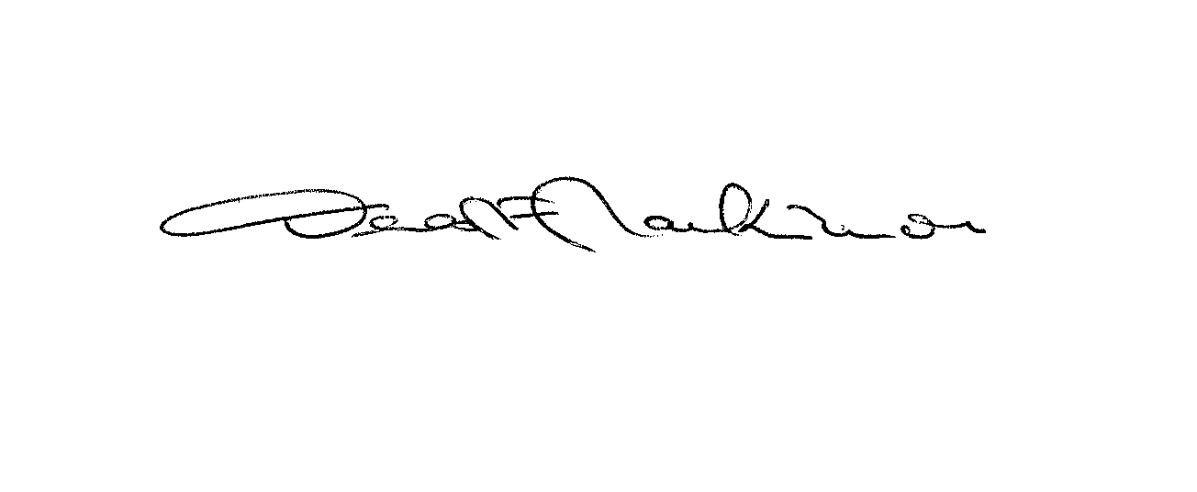
Date: 11.08.2016
_________________________

Signature of WIHEA Representative:
Comments: (optional)

Signature: Name: (please print)
_________________________ _________________________
Date:
_________________________

Please complete electronically and email it to WIHEA@warwick.ac.uk

Alternatively, an audio recording or video containing information on all the sections can be submitted, but must also include a written review of the Project Budget.

A final project review meeting will be arranged, to discuss the project and
dissemination across the university.

